Kubernetes Task-05
- Create a namespace dev-environment and apply a resource-based quota that restricts the number of pods to 3 and services to 2.
- Create a pod in the prod-environment namespace with 0.2 CPU and 200Mi memory requests, and 0.5 CPU and 500Mi memory limits.
- In the staging-environment namespace, set a Limit Range that assigns default CPU and memory limits (300m CPU, 600Mi memory) and applies a minimum and maximum CPU.
- Create a pod and a NodePort service in the default namespace, then create another pod in the test namespace and communicate between them using Service DNS.
- Apply a Limit Range with a max limit/request ratio of 2 for memory in the performance-environment namespace, and test by creating a pod with mismatched resource requests and limits.

Task 1: Namespace and Resource Quota

Objective
Create a dev-environment namespace and apply a ResourceQuota that allows a maximum of 3 pods and 2 services.

Implementation Steps

1.1 Create the namespace
kubectl create namespace dev-environment

1.2 Create the ResourceQuota YAML
vi dev-resource-quota.yaml
Add:
apiVersion: v1
kind: ResourceQuota
metadata:
name: dev-quota
namespace: dev-environment
spec:
hard:
pods: "3"
services: "2"
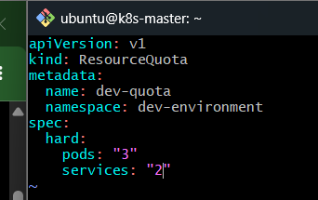

1.3 Apply the quota
kubectl apply -f dev-resource-quota.yaml

1.4 Verify the quota
kubectl get resourcequota -n dev-environment
kubectl describe resourcequota dev-quota -n dev-environment
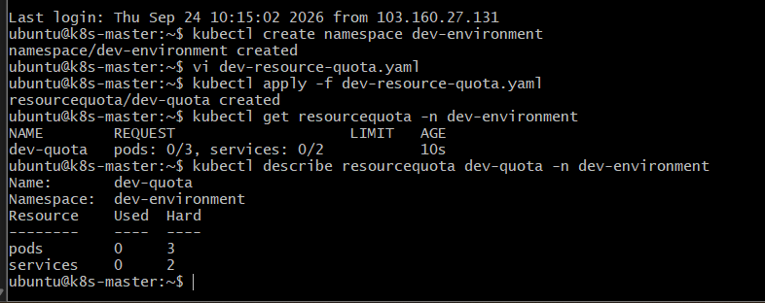

Task 2: Pod with Resource Requests and Limits

Objective
Create a pod in the prod-environment namespace with:
- CPU request: 0.2 CPU
- Memory request: 200Mi
- CPU limit: 0.5 CPU
- Memory limit: 500Mi

Implementation Steps

2.1 Create the namespace
kubectl create namespace prod-environment

2.2 Create the pod YAML
vi prod-pod.yaml
Add:
apiVersion: v1
kind: Pod
metadata:
name: prod-pod
namespace: prod-environment
spec:
containers:
- name: nginx
image: nginx
resources:
requests:
cpu: "200m"
memory: "200Mi"
limits:
cpu: "500m"
memory: "500Mi"
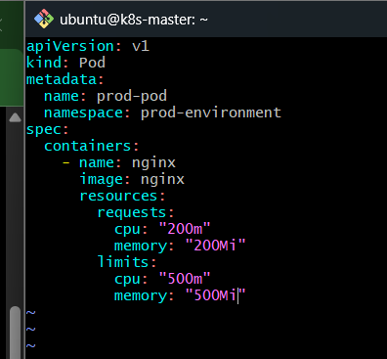

2.3 Create the pod
kubectl apply -f prod-pod.yaml

2.4 Verify
kubectl get pod -n prod-environment
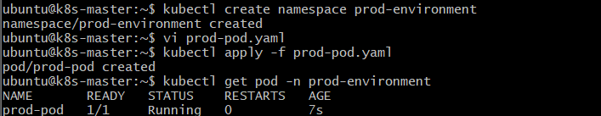

kubectl describe pod prod-pod -n prod-environment

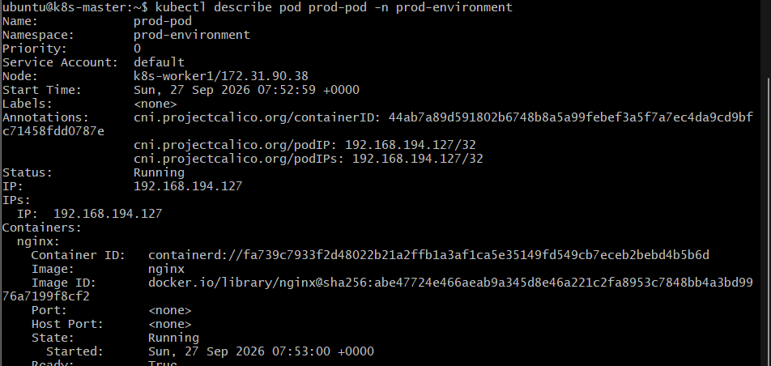

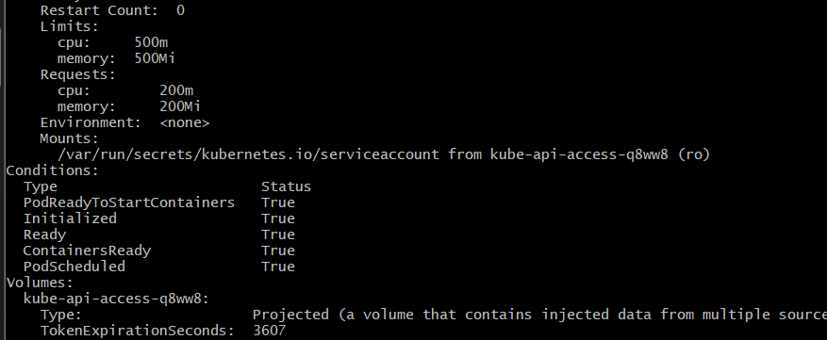

Task 3: LimitRange in Staging

Objective
Create a staging-environment namespace and configure a LimitRange with:
- Default CPU limit: 300m
- Default memory limit: 600Mi
- Minimum CPU
- Maximum CPU

Implementation Steps

3.1 Create the namespace
kubectl create namespace staging-environment

3.2 Create the LimitRange YAML
vi staging-limitrange.yaml
Add:
apiVersion: v1
kind: LimitRange
metadata:
name: staging-limits
namespace: staging-environment
spec:
limits:
- type: Container
default:
cpu: "300m"
memory: "600Mi"
min:
cpu: "100m"
max:
cpu: "500m"

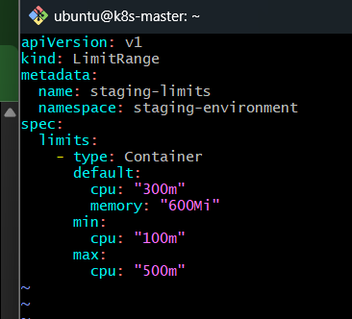

3.3 Apply the LimitRange
kubectl apply -f staging-limitrange.yaml

3.4 Verify
kubectl get limitrange -n staging-environment
kubectl describe limitrange staging-limits -n staging-environment
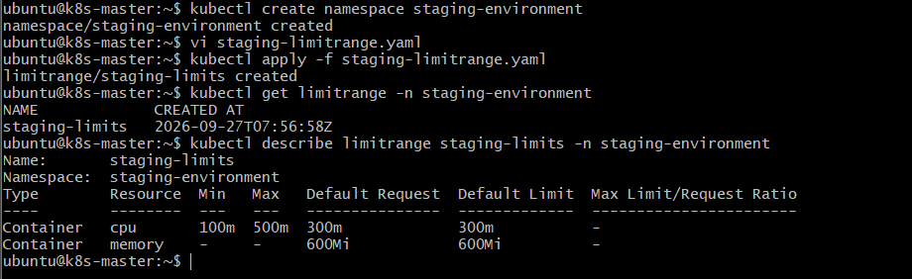

Task 4: Service DNS Communication

Objective
Create a pod and NodePort service in the default namespace, create another pod in the test namespace, and communicate with the first pod using Kubernetes Service DNS.

Implementation Steps

4.1 Create the test namespace
kubectl create namespace test

4.2 Create the application pod in default
vi dns-pod.yaml
Add:
apiVersion: v1
kind: Pod
metadata:
name: dns-pod
labels:
app: dns-app
spec:
containers:
- name: nginx
image: nginx
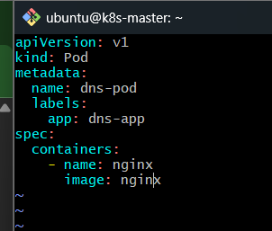

4.3 Apply the pod
kubectl apply -f dns-pod.yaml
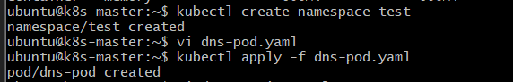

4.4 Create the NodePort service
vi dns-service.yaml
Add:
apiVersion: v1
kind: Service
metadata:
name: dns-service
namespace: default
spec:
type: NodePort
selector:
app: dns-app
ports:
- port: 80
targetPort: 80
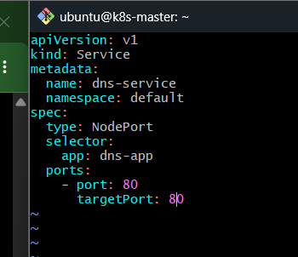

4.5 Apply the service
kubectl apply -f dns-service.yaml

4.6 Verify the service
kubectl get svc dns-service
kubectl get endpoints dns-service
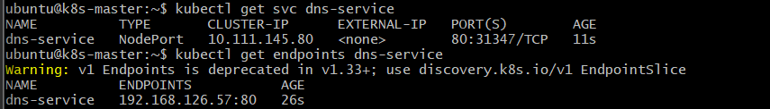

4.7 Create the client pod in test
kubectl run test-pod \
--image=busybox:1.36 \
--restart=Never \
-n test \
--command -- sleep 3600

4.8 Open a shell inside the test pod
kubectl exec -it test-pod -n test -- sh

4.9 Communicate using Service DNS
From inside the test-pod:
wget -qO- http://dns-service.default.svc.cluster.local
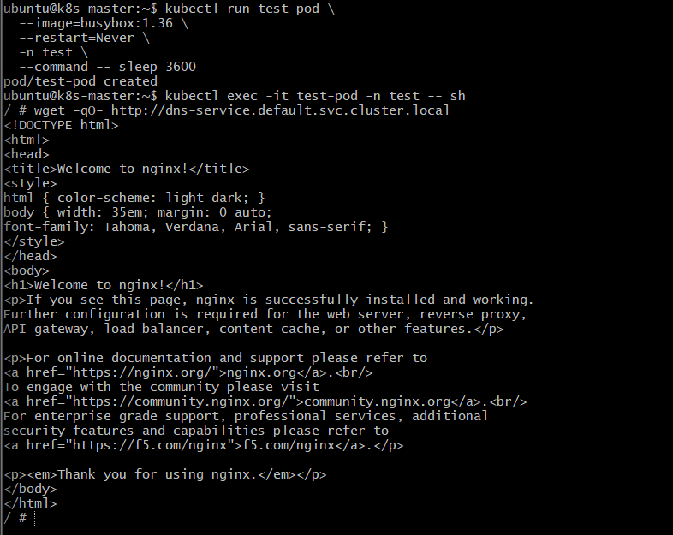
The DNS structure is:
dns-service.default.svc.cluster.local
│ │
│ └── Namespace
└───────────── Service

Task 5: Memory Limit/Request Ratio

Objective
Create a performance-environment namespace with a LimitRange that requires the memory limit/request ratio to be at most 2, then test it with a pod whose memory limit exceeds the allowed ratio.

Implementation Steps

5.1 Create the namespace
kubectl create namespace performance-environment

5.2 Create the LimitRange
vi performance-limitrange.yaml
Add:
apiVersion: v1
kind: LimitRange
metadata:
name: performance-limits
namespace: performance-environment
spec:
limits:
- type: Container
maxLimitRequestRatio:
memory: "2"
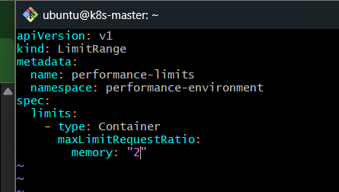

5.3 Apply the LimitRange
kubectl apply -f performance-limitrange.yaml
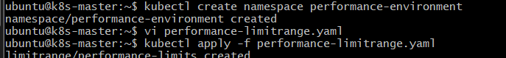

5.4 Verify
kubectl describe limitrange performance-limits -n performance-environment
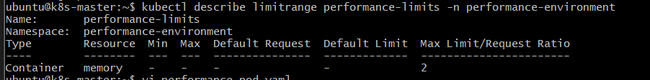

5.5 Create a pod with a mismatched memory ratio
Here the ratio is:
Memory limit / Memory request
= 600Mi / 200Mi
= 3
The allowed maximum is 2, so this pod should be rejected.
vi performance-pod.yaml
Add:
apiVersion: v1
kind: Pod
metadata:
name: performance-pod
namespace: performance-environment
spec:
containers:
- name: nginx
image: nginx
resources:
requests:
memory: "200Mi"
limits:
memory: "600Mi"
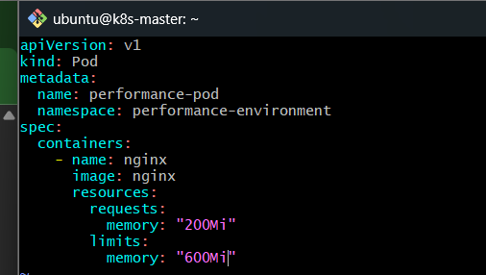

5.6 Apply the pod
kubectl apply -f performance-pod.yaml

5.7 Check the pod
kubectl get pod -n performance-environment
The API server should reject the pod because:
600Mi / 200Mi = 3
while the configured maximum ratio is:
2
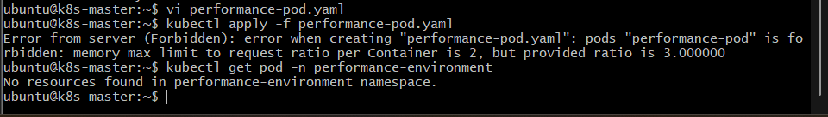

Outcome
The performance-environment namespace was configured with a LimitRange that restricts the maximum memory limit-to-request ratio to 2.
A test pod was created with:
- Memory request: 200Mi
- Memory limit: 600Mi
- Ratio: 600 / 200 = 3
Kubernetes rejected the pod because the ratio 3 exceeds the configured maximum of 2.
Result: The memory maxLimitRequestRatio policy is working correctly.

